**Chapter - 1**

**INTRODUCTION**

Machine learning is a subfield of artificial intelligence (AI). The goal of machine learning generally is to understand the structure of data and fit that data into models that can be understood and utilized by people. Although machine learning is a field within computer science, it differs from traditional computational approaches. In traditional computing, algorithms are sets of explicitly programmed instructions used by computers to calculate or problem solve. Machine learning algorithms instead allow for computers to train on data inputs and use statistical analysis in order to output values that fall within a specific range. Because of this, machine learning facilitates computers in building models from sample data in order to automate decision- making processes based on data inputs.

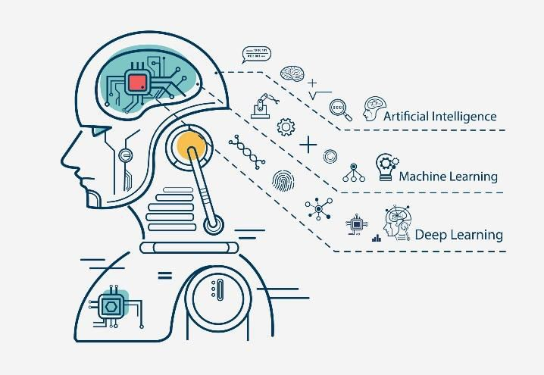

Fig 1.1: Introduction to ML

### 1.1 How does Machine Learning work:

Machine learning is a form of artificial intelligence (AI) that teaches computers to think in a similar way to how humans do learning and improving upon past experiences. It works by exploring data, identifying patterns, and involves minimal human intervention. Almost any task that can be completed with a data- defined pattern or set of rules can be automated with machine learning. This allows companies to transform processes that were previously only possible for humans to perform think responding to customer service calls, bookkeeping, and reviewing resumes.

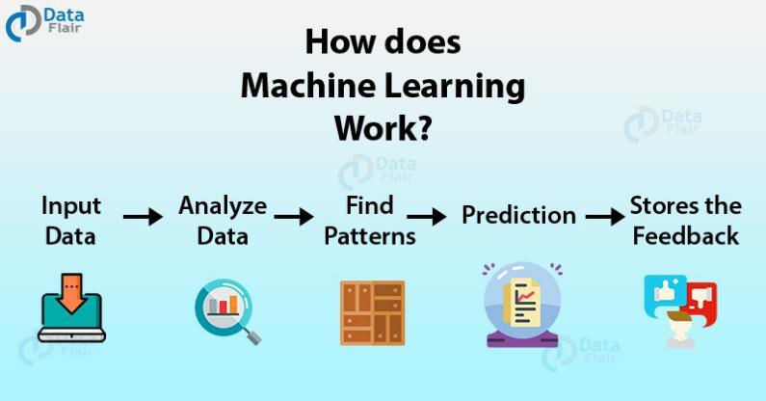

Fig 1.2: How does Machine Learning Work

### 1.2 Machine Learning Techniques:

Machine learning uses two types of techniques:

* **Supervised learning**: which trains a model on known input and output data so that it can predict future outputs. It allows you to collect data or produce a data output from a previous ML deployment. Supervised learning is exciting because it works in much the same way humans actually learn.
* **Unsupervised learning**: which finds hidden patterns or intrinsic structures in input data. helps you find all kinds of unknown patterns in data. In unsupervised learning, the algorithm tries to learn some inherent structure to the data with only unlabeled examples. Two common unsupervised learning tasks are clustering and dimensionality reduction.

### 

Fig 1.3: Techniques of Machine Learning

This report contains the “ADANI STOCK ANALYSIS USING R” based on the dataset which contains the attributes such as Date, Open, High, low, close, Adj close and volume. The Prediction is done through various machine learning algorithms such as

* Linear Regression
* Logistic Regression
* Clustering or k – Means Algorithm
* Association or Apriori Algorithm
* K-NearestNeighbours Classifier

By using these algorithms we get a detailed view of the tested results and the trained results of the machine. We can visualize the results using Boxplot, Correlation matrix, jointplot and so on.

**1.3 Objectives**

The objectives of this project are as follows:

1. To experiment with different classification methods to see which yields the highest accuracy

2. To determine which features are the most indicative of a good quality wine

**Chapter - 2**

# COMPANY PROFILE

**2.1 Company Profile:**

The Tech Fortune group was originally incepted in 2013 to focus only on EPC assignment of Infra and Real Estate Projects. Later the Company shifted its focus towards software development, Training ,BPO, Sourcing, Food Business, Health Care and Strategic Advisory Services. The Tech Fortune group Tech Fortune was born in 2013 with an objective to create a landmark initiative by a group of highly qualified technology oriented professionals in the software domain. A Software development Firm head quartered in Vijayapur and operating for 5 years in with 3 offices across Karnataka. Since its inception in 2013, Tech fortune group has grown rapidly with the help of its valued Customers, professionals & Business Associates who have been continuously contributing and monitoring the Company’s business activities in the operations of Project Management, Education Consultancy, QMS and Six Sigma implementation and many other domain of expertise.

Tech Fortune Technologies, is an emerging technology organisation in the fields of business process outsourcing. Software development, end-to-end ERP solutions, Artificial Intelligence, Blockchain technology with a focus on providing customized solutions to the various business needs of a diverse global client.

## Mission:

Being slow and steady, our mission is to gain the confidence of our clients and by dint of our integrity, innovation and dynamism, deliver their requirements on time with full quality thus bridging the gap between demand and delivery.

**2.3 Vission:**

With an unyielding focus on integrity and backed by strong founders and management team , Sourcing wants to make a mark in the field of IT services by applying innovation to simplify complex business processes and add value to clients’ business

**Chapter - 3**

**LITERATURE SURVEY**

**3.1 Linear Regression**

The main goal of regression is the construction of an efficient model to predict the dependent attributes from a bunch of attribute variables. A regression problem is when the output variable is either real or a continuous value i.e salary, weight, area, etc.

We can also define regression as a statistical means that is used in applications like housing, investing, etc. It is used to predict the relationship between a dependent variable and a bunch of independent variables. Let us take a look at various types of regression techniques.

**Advantages**

* Linear regression performs exceptionally well for linearly separable data
* Easier to implement, interpret and efficient to train
* It handles overfitting pretty well using dimensionally reduction techniques, regularization, and cross-validation
* One more advantage is the extrapolation beyond a specific data set

**Disadvantages**

* The assumption of linearity between dependent and independent variables
* It is often quite prone to noise and overfitting
* Linear regression is quite sensitive to outliers
* It is prone to multicollinearity

**3.2 Logistic Regression**

Introduction to Logistic Regression: Logistic regression is a supervised learning classification algorithm used to predict the probability of a target variable. The nature of target or dependent variable is dichotomous, which means there would be only two possible classes. In simple words, the dependent variable is binary in nature having data coded as either 1 (stands for success/yes) or 0 (stands for failure/no). Mathematically, a logistic regression model predicts P(Y=1) as a function of X.

**Binary or Binomial:** In such a kind of classification, a dependent variable will have only two possible types either 1 or 0. For example, these variables may represent success or failure, yes or no, win or loss etc.

### Advantages

* It is a widely used technique because it is very efficient, does not require too many computational resources, it’s highly interpretable, it doesn’t require input features to be scaled, it doesn’t require any tuning, it’s easy to regularize, and it outputs well- calibrated predicted probabilities.
* Like linear regression, logistic regression does work better when you remove attributes that are unrelated to the output variable as well as attributes that are very similar (correlated) to each other. Therefore Feature Engineering plays an important role in regards to the performance of Logistic and also Linear Regression.
* Another advantage of Logistic Regression is that it is incredibly easy to implement and very efficient to train. I typically start with a Logistic Regression model as a benchmark and try using more complex algorithms.
* Because of its simplicity and the fact that it can be implemented relatively easy and quick, Logistic Regression is also a good baseline that you can use to measure the performance of other more complex Algorithms

### Disadvantages

* A disadvantage of it is that we can’t solve non-linear problems with logistic regression since it’s decision surface is linear.

## 3.4. K-NearestNeighbours Classifier

K-nearest neighbors (KNN) algorithm is a type of supervised ML algorithm which can be used for both classification as well as regression predictive problems. However, it is mainly used for classification predictive problems in industry. The following two properties would define KNN well

* Lazy learning algorithm − KNN is a lazy learning algorithm because it does not have a specialized training phase and uses all the data for training while classification.
* Non-parametric learning algorithm − KNN is also a non-parametric learning algorithm because it doesn’t assume anything about the underlying data.

**Step 1** − for implementing any algorithm, we need dataset. So during the first step of KNN, we must load the training as well as test data.

**Step 2** − Next, we need to choose the value of K i.e. the nearest data points.

**Step 3** − for each point in the test data do the following

* **3.1** − Calculate the distance between test data and each row of training data with the help of any of the method namely: Euclidean, Manhattan or Hamming distance. The most commonly used method to calculate distance is Euclidean.
* **3.2** − Now, based on the distance value, sort them in ascending order.
* **3.3** − Next, it will choose the top K rows from the sorted array.
* **3.4** − Now, it will assign a class to the test point based on most frequent class of these rows.

**Step 4** − End

### Advantages

* It is very simple algorithm to understand and interpret.
* It is very useful for nonlinear data because there is no assumption about data in this algorithm.
* It is a versatile algorithm as we can use it for classification as well as regression.

### It has relatively high accuracy but there are much better supervised learning models than KNN

### Disadvantages

* It is computationally a bit expensive algorithm because it stores all the training data.
* High memory storage required as compared to other supervised learning algorithms.
* Prediction is slow in case of big N.

### 3.5 K Means Clustering

### K Means Clustering in R Programming is an Unsupervised Non-linear algorithm that cluster data based on similarity or similar groups. It seeks to partition the observations into a pre-specified number of clusters. Segmentation of data takes place to assign each training example to a segment called a cluster. In the unsupervised algorithm, high reliance on raw data is given with large expenditure on manual review for review of relevance is given. It is used in a variety of fields like Banking, healthcare, retail, Media, etc.

K-Means clustering groups the data on similar groups. The algorithm is as follows:

1. Choose the number K clusters.
2. Select at random K points, the centroids (Not necessarily from the given data).
3. Assign each data point to closest centroid that forms K clusters.
4. Compute and place the new centroid of each centroid.
5. Reassign each data point to new cluster.

**Chapter - 4**

**INTERNSHIP DOMAIN**

**4.1 Introduction**

The technology that promises to bring massive changes to the world next years is ML. Machine learning is a subfield of the Artificial Intelligence research and got the highest spotlight in business.

ML represents a new era in software development where computers, gadgets, and other devices do not require special programming to complete tasks anymore. Instead, they can collect and analyze information that is needed to draw appropriate conclusions and learn during program performance. Now machines can accumulate previous experience in order to make decisions as it occurs among human beings. Of course, the process of learning requires special algorithms that would “teach” machines. That is why, at The App Solutions, we use machine learning in mobile app development.

To understand the scale of ML industry, let's take a general outlook on the Artificial Intelligence market. According to Bank of America Merrill Lynch, over the next five years, the market will extend to $153 billion compared to $58 billion in 2014.

Venture Scanning gives an info graphic that summarizes the Artificial Intelligence market and shows funding of every category. The chart shows that ML applications category is leading with over $2 billion market share. This is three times more than the total funding of the next Natural Learning Processing group.

**Basic Difference in ML and Traditional Programming?**

Traditional Programming :We feed in DATA (Input) + PROGRAM (logic), run it on machine and get output. • Machine Learning: We feed in DATA (Input) + Output, run it on machine during training and the machine creates its own program(logic), which can be evaluated while testing.

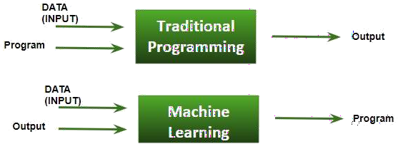

### What does exactly learning means for a computer?

A computer is said to be learning from Experiences with respect to some class of Tasks, if its performance in a given Task improves with the Experience.

A computer program is said to learn from experience E with respect to some class of tasks T and performance measure P, if its performance at tasks in T, as measured by P, improves with experience E

Example: playing checkers.

E = the experience of playing many games of checkers T = the task of playing checkers.

P = the probability that the program will win the next game

In general, any machine learning problem can be assigned to one of two broad classifications:

Supervised learning and Unsupervised learning.

### How things work in reality: -

Talking about online shopping, there are millions of users with unlimited range of interests with respect to brands, colors, price range and many more. While online shopping, buyers tend to search for a number of products. Now, searching a product frequently will make buyer’s Facebook, web pages, search engine or that online store start recommending or showing offers on that particular product. There is no one sitting over there to code such task for each and every user, all this task is completely automatic.

Here, ML plays its role. Researchers, data scientists, machine learners build models on machine using good quality and huge amount of data and now their machine is automatically performing and even improving with more and more experience and time.

Traditionally, advertisement was only done using newspapers, magazines and radio but now technology has made us smart enough to do Targeted advertisement (online ad system) which is a way more efficient method to target most receptive audience.

Even in health care also, ML is doing a fabulous job. Researchers and scientists have prepared models to train machines for detecting cancer just by looking at slide – cell images. For humans to perform this task it would have taken a lot of time. But now, no more delay, machines predict the chances of having or not having cancer with some accuracy and doctors just have to give a assurance call, that’s it. The answer to – how is this possible is very simple -all that is required, is, high computation machine, large amount of good quality image data, ML model with good algorithms to achieve state-of- the-art results.

Doctors are using ML even to diagnose patients based on different parameters under consideration.

You all might have use IMDB ratings, Google Photos where it recognizes faces, Google Lens where the ML image-text recognition model can extract text from the images you feed in, Gmail which categories Email as social, promotion, updates or forum using text classification, which is a part of ML.

### How ML works?

Gathering past data in the form of text file, excel file, images or audio data. The more better the quality of data, the better will be the model learning Data Processing – Sometimes, the data collected is in the raw form and it needs to be rectified.

Example: if data has some missing values, then it has to be rectified. If data is in the form of text or images then converting it to numerical form will be required, be it list or array or matrix. Simply, Data is to be made relevant and understandable by the machine Building up models with suitable algorithms and techniques and then training it.

Testing our prepared model with data which was not feed in at the time of training and so evaluating the performance – score, accuracy with high level of precision.

### Prerequisites to learn ML:

* + - Linear Algebra
    - Statistics and Probability
    - Calculus
    - Graph theory
    - Programming Skills – Language such as Python, R, MATLAB, C++ or Octave

# 4.2 Tools Used

### List of tools used during internship

### R

### R

### R is a programming language and open-source software environment for statistical computing and graphics. It is widely used in data analysis, data visualization, and machine learning applications. R was created by Ross Ihaka and Robert Gentleman at the University of Auckland, New Zealand in the mid-1990s.

### One of the strengths of R is its extensive library of statistical and graphical methods. R provides a variety of tools for data manipulation, exploration, visualization, and modeling. These tools allow users to perform tasks such as importing and exporting data, filtering and sorting data, summarizing and transforming data, and creating charts and plots.

### R is also highly extensible, allowing users to create their own packages and functions to extend its capabilities. R has a large and active community of users and developers who contribute to the development of packages and support forums.

### R can be run on a variety of operating systems including Windows, macOS, and Linux. It can also be integrated with other programming languages such as Python and C++. R is free to use and can be downloaded from the Comprehensive R Archive Network (CRAN) website.

### It is used for:

### Data Analysis: R is widely used for data analysis, including data cleaning, transformation, and visualization. It provides a variety of tools and packages for exploring and analyzing data.

### Statistics: R is designed for statistical computing and provides a wide range of statistical methods and tests. It is widely used in academic and research fields for statistical analysis.

### Machine Learning: R provides a range of packages for machine learning and predictive modeling. It is used for tasks such as regression analysis, clustering, decision trees, and more.

### Graphics and Data Visualization: R provides a range of tools and packages for creating high-quality graphics and data visualizations. It is used for creating charts, plots, and maps.

### Reproducible Research: R is used for reproducible research, where code, data, and analysis are all shared and can be replicated by others. This helps to ensure transparency and the validity of research findings.

### Overall, R is a powerful and versatile programming language that is used in a wide range of applications, from scientific research to business analytics to data journalism. Its flexibility and extensibility make it a popular choice for data analysis and visualization.

### Objectives

There are many objectives that can be achieved using the R programming language, including:

* Data Manipulation: R provides powerful tools for data manipulation such as subsetting, merging, sorting, filtering, and transforming data.
* Data Visualization: R offers a wide range of tools for data visualization, such as scatter plots, line charts, bar charts, histograms, and heat maps.
* Statistical Analysis: R is widely used for statistical analysis, such as hypothesis testing, regression analysis, and time series analysis.
* Machine Learning: R has a vast collection of packages for machine learning, including classification, clustering, and prediction models.
* Data Mining: R can be used for data mining tasks such as association rule mining, clustering, and anomaly detection.
* Text Analysis: R has many packages for text analysis, including natural language processing (NLP) and sentiment analysis.
* Web Development: R can be used for web development, with packages like Shiny that allow users to create interactive web applications using R code.
* Reproducible Research: R is designed to support reproducible research, making it easy to share code, data, and results with others.
* Overall, the objectives of using R are to analyze data, visualize data, and build models that can help us gain insights and make informed decisions.

**Chapter-5**

**TASK PERFORMED**

### PROJECT TITLE: Adani Stock Price Analysis using R

### Introduction to Project

### Adani stock analysis using R is a project report that analyzes the historical stock price data of Adani Group, an Indian multinational conglomerate company. The report aims to provide insights into the performance of Adani Group's stock over time and to identify trends and patterns that can be used to make investment decisions.

### The project report involves importing the Adani Group's stock data into R, cleaning and transforming the data, and performing various statistical analyses using R packages such as tidyverse, dplyr, ggplot2, and quantmod. The analyses include computing descriptive statistics, visualizing trends in the data using time series plots, and applying technical analysis techniques such as moving averages and relative strength index (RSI).

### The project report also includes a discussion of the findings and their implications for investment decisions. This includes evaluating the performance of Adani Group's stock over time, identifying trends and patterns in the data, and making recommendations for future investments based on the analysis.

### Overall, the Adani stock analysis using R project report provides a comprehensive analysis of the historical performance of Adani Group's stock and serves as a valuable resource for investors looking to make informed decisions about their investments in the company.

# 5.2 Software/Hardware Requirements

Software Requirements:

* R programming language (available for free at <https://cran.r-project.org/>)
* Integrated Development Environment (IDE) for R, such as RStudio (available for free at <https://rstudio.com/>)

Hardware Requirements:

* Operating System: Windows, Mac OS X, or Linux
* Processor: Any modern processor, but a multicore processor is recommended for large datasets
* RAM: At least 4 GB, but 8 GB or more is recommended for working with larger datasets
* Disk Space: At least 1 GB of free space is required for R and its packages, but more disk space will be required if you work with large datasets or store many files

### Modules Description

### Multi-linear Regression:

### Multiple linear regression is a statistical technique used to model the relationship between a dependent variable and two or more independent variables. It assumes a linear relationship between the variables, and the goal is to determine the coefficients of the independent variables that best predict the dependent variable.

### In R, you can perform multiple linear regression using the lm() function. Here is an example using the built-in mtcars dataset:

### # Load the mtcars dataset

### data(mtcars)

### # Fit a multiple linear regression model with mpg as the dependent variable

### model <- lm(mpg ~ wt + hp + drat, data = mtcars)

### # Print the model summary

### summary(model)

### In this example, we are fitting a model with mpg (miles per gallon) as the dependent variable and wt (weight), hp (horsepower), and drat (rear axle ratio) as the independent variables. The lm() function takes two arguments: the formula specifying the model (mpg ~ wt + hp + drat) and the data frame containing the variables (data = mtcars).

### The summary() function prints a summary of the model, including the coefficients of the independent variables and various statistics for assessing the model fit.

### You can also use the predict() function to make predictions with the model:

### # Make predictions for a new data point with

### wt = 3.5, hp = 200, and drat = 3.9

### new_data <- data.frame(wt = 3.5, hp = 200, drat = 3.9)

### predicted_mpg <- predict(model, newdata = new_data)

### This code creates a new data frame with the independent variable values for a new data point, and then uses the predict() function to predict the value of the dependent variable (mpg) for that data point. The predict() function takes two arguments: the fitted model (model) and the new data (newdata = new_data). The predicted value of mpg is stored in the predicted_mpg variable.

### K – Means Clustering:

### K-means clustering is an unsupervised machine learning technique used to group similar data points together based on their distance to the center of each group. The goal is to minimize the sum of squared distances between each data point and its assigned center, also known as the within-cluster sum of squares (WCSS).

### In R, you can perform k-means clustering using the kmeans() function. Here is an example using the built-in iris dataset:

### # Load the iris dataset

### data(iris)

### # Select the variables to cluster

### variables <- iris[, 1:4]

### # Fit a k-means model with 3 clusters

### model <- kmeans(variables, centers = 3)

### # Print the model summary

### print(model)

### In this example, we are selecting the first four variables (Sepal.Length, Sepal.Width, Petal.Length, Petal.Width) from the iris dataset to cluster. The kmeans() function takes two arguments: the data to cluster (variables) and the number of clusters (centers = 3). The print() function prints a summary of the model, including the cluster assignments for each data point and the within-cluster sum of squares (WCSS) for each cluster.

### You can also visualize the results using a scatterplot:

### # Plot the data with cluster assignments

### library(ggplot2)

### ggplot(iris, aes(x = Sepal.Length, y = Sepal.Width, color = factor(model$cluster))) + geom_point() +labs(title = "K-Means Clustering with 3 Clusters")

### This code creates a scatterplot of the Sepal.Length and Sepal.Width variables, with each data point colored according to its assigned cluster. The factor(model$cluster) function converts the cluster assignments from numeric to factor, so that they are interpreted as categorical values for coloring the points. The ggplot2 library is required for creating the plot.

### You can also use the elbow method to choose the optimal number of clusters:

### # Compute the WCSS for different numbers of clusters

### wcss <- sapply(1:10, function(k){kmeans(variables, k)$tot.withinss})

### # Plot the WCSS versus the number of clusters

### plot(1:10, wcss, type = "b", xlab = "Number of Clusters", ylab = "WCSS",

### main = "Elbow Method for Optimal Number of Clusters")

### This code computes the WCSS for different numbers of clusters (from 1 to 10) using the kmeans() function, and then plots the WCSS versus the number of clusters. The elbow of the plot corresponds to the optimal number of clusters, where adding more clusters does not significantly decrease the WCSS.

**Chapter – 6**

**PROBLEM STATEMENT**

## 6.1 Problem Definition:

The objective of this project is to perform a comprehensive analysis of Adani Group's stock prices using R programming language. The project aims to extract, clean and preprocess the Adani Group's stock data from reliable sources and perform various analytical tasks on the data such as descriptive analysis, correlation analysis, trend analysis, and predictive analysis to understand the stock's past trends and future performance. The project also involves visualizing the data in graphical formats such as line plots, bar charts, and scatter plots to help identify any underlying patterns or trends. The analysis will help investors and stakeholders make informed decisions about Adani Group's stock by identifying opportunities, risks and understanding the potential returns on investment.

The Adani stock price dataset contains different information about Adani stocks. It has 251 instances with 07 variables each. The dataset is good for classification and regression tasks. The model can be used to predict and analysis of Adani stock price. Perform various different algorithms like regression, decision tree, Association rule, etc. and differentiate between the models and analyze their performances.

Here I am performing various different Classification algorithms like Logistics Regression, Decision Tree Classifier, Random Forest Classifier, Stochastic Gradient Descent Classifier, Naive Bayes Classifier, K- NearestNeighbours Classifier and Support Vector Machine (SVM) and trying to differentiate between the models and analyze their performances.

**Chapter – 7**

# DATA SUMMARY

## Attribute Information:

The analysis of Adani stock price is determined by 07 input variables:

* + 1. Open
    2. High
    3. Low
    4. Close
    5. Date
    6. Adj Close
    7. Volume

**Output variable:** Analysis using Graph and scatter chart.

## Missing Attribute Values: None

**Chapter - 8**

**REFLECTION NOTES**

I had been interned in the course and I have a very nice experience to share. The team was amazing and flexible. They are ready to help us at our convenience. There was lot to know about the subject, sensors in specific. To me from CS background they made it as a very easy task. I want to thank everyone who helped me to make it possible.”

"I thoroughly enjoyed my internship this summer and now have very valuable experience under my belt. I know this will help when looking for jobs and needing references. I was dreading it in the beginning, but now I am so happy it was required. As much as the curriculum changes, I hope that class remains constant."

"We all know that practical experience is the best, and internships give students that hands-on experience they need. I feel that quality internships are essential to develop key skills that you can't get in a classroom. Skills such as multitasking, communicating, learning to deal with diversity, and dealing with deadlines are different when you are working for someone else, not yourself like you do in college. Internships are also a great way to network with people in the industry. My boss and co-workers were great about giving me contacts and referring me to open positions in the industry."

"I learned that customer service is hard. You can not please everyone. There are people in this world that are simply difficult. I have learned that stressing over little things will not get me anywhere. I have learned to work well as a team and that without my counterparts the work would not get done. Another aspect that I learned throughout my internship is to never be afraid to ask lots of questions. By asking questions I got answers."

"I learned more than I ever expected. I felt in the beginning that I would really have a head start being that I am a senior and have taken all my classes already but I realized that I don’t think any amount of classes will ever prepare you for all the world has to offer. Don’t get me wrong, I feel that Auburn did a wonderful job teaching me but I feel that it is most valuable if combined with first hand work .

I feel that during my time interning my most challenging part of my work was having to share my tasks and coordinate my work with others. I have always been kind of a perfectionist and liked to have things done my way so working with others and sharing duties was a slight change I must say. It took me a couple of weeks to really feel comfortable allowing someone else to share my work but eventually I learned it was ok and that two heads were better than one."

**Chapter – 9**

**RESULTS AND INTERNSHIP OUTCOMES**

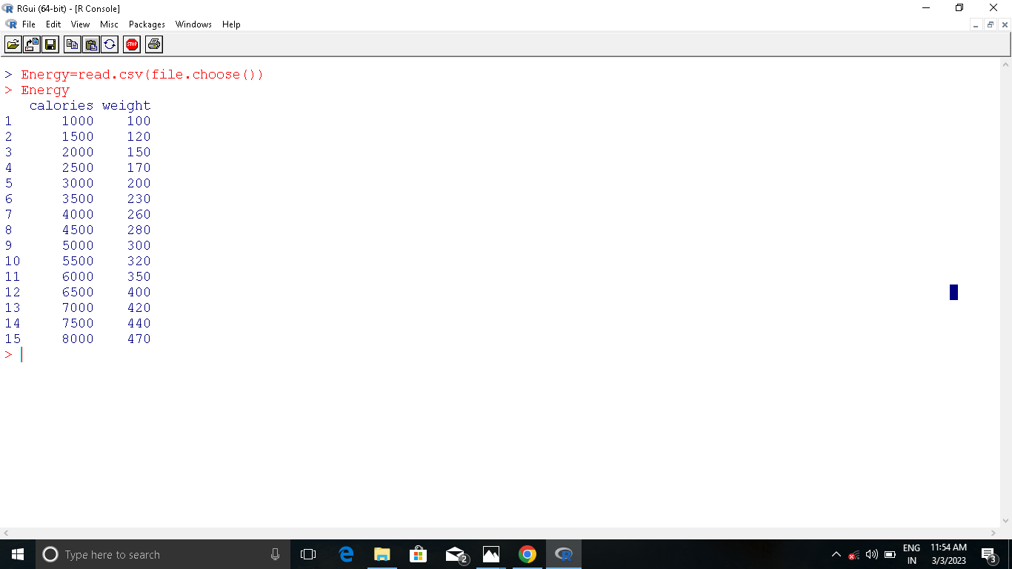

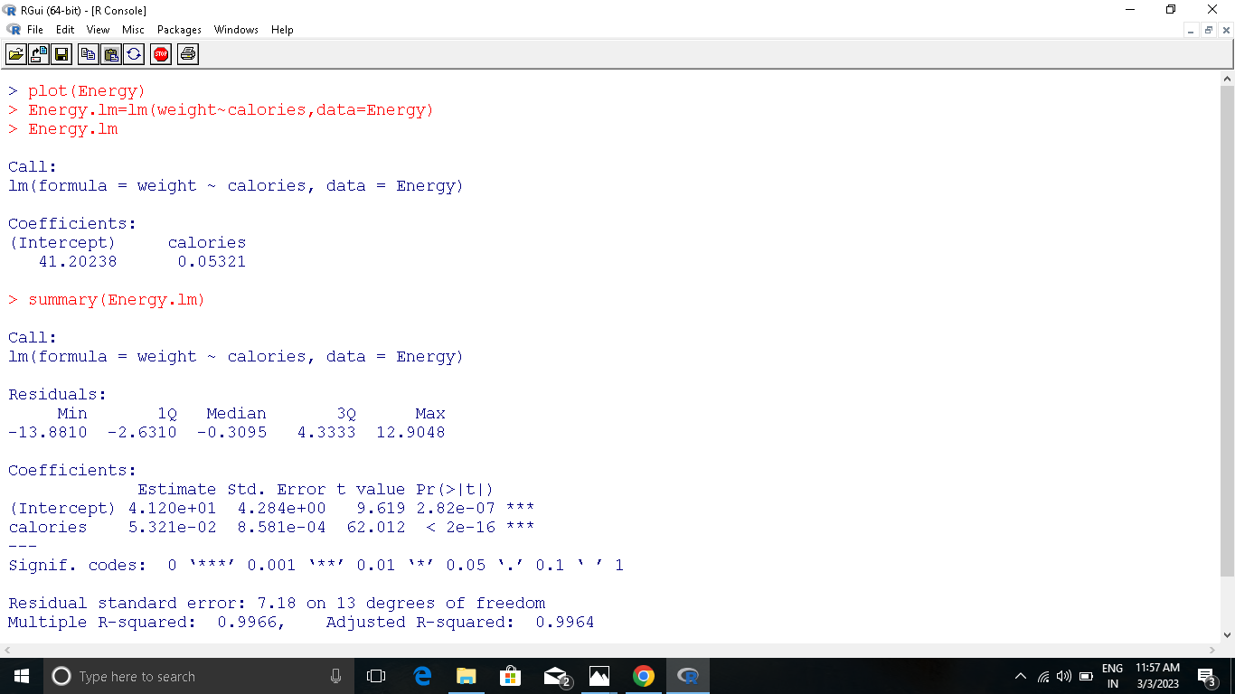

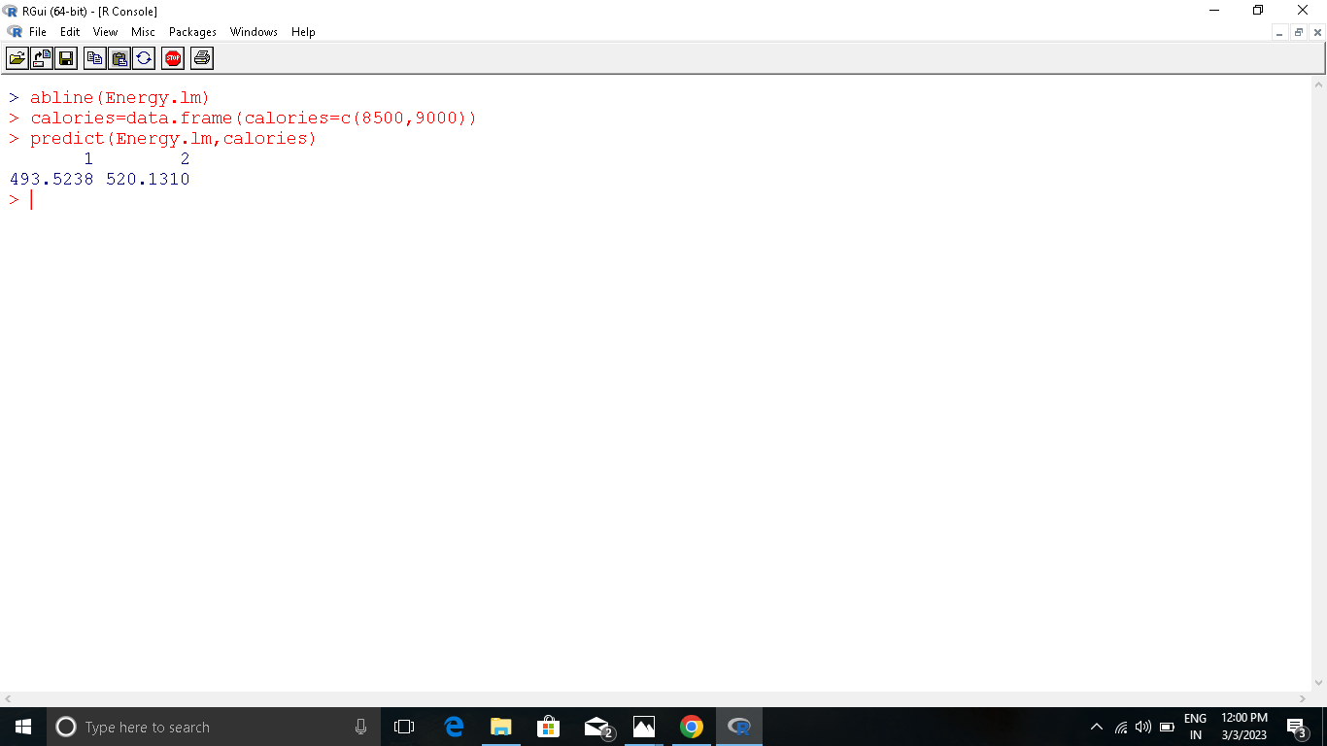

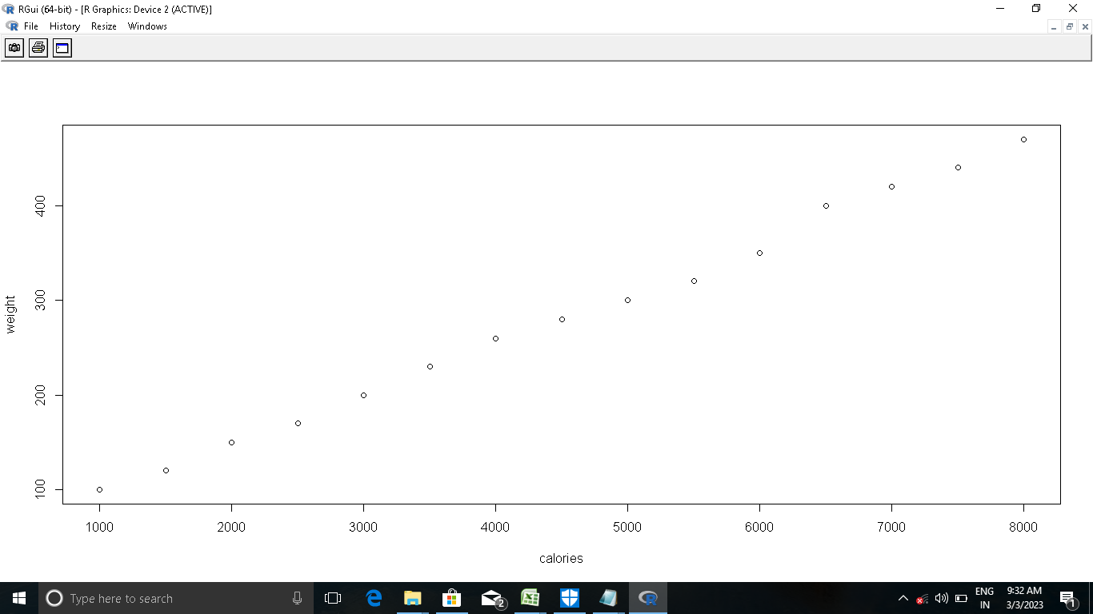

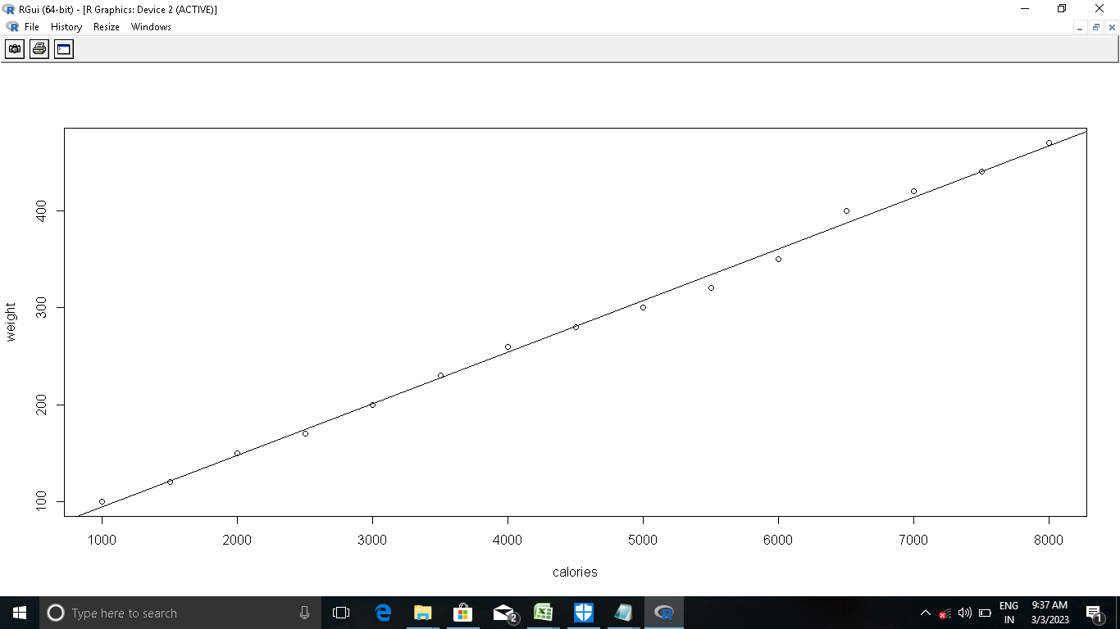

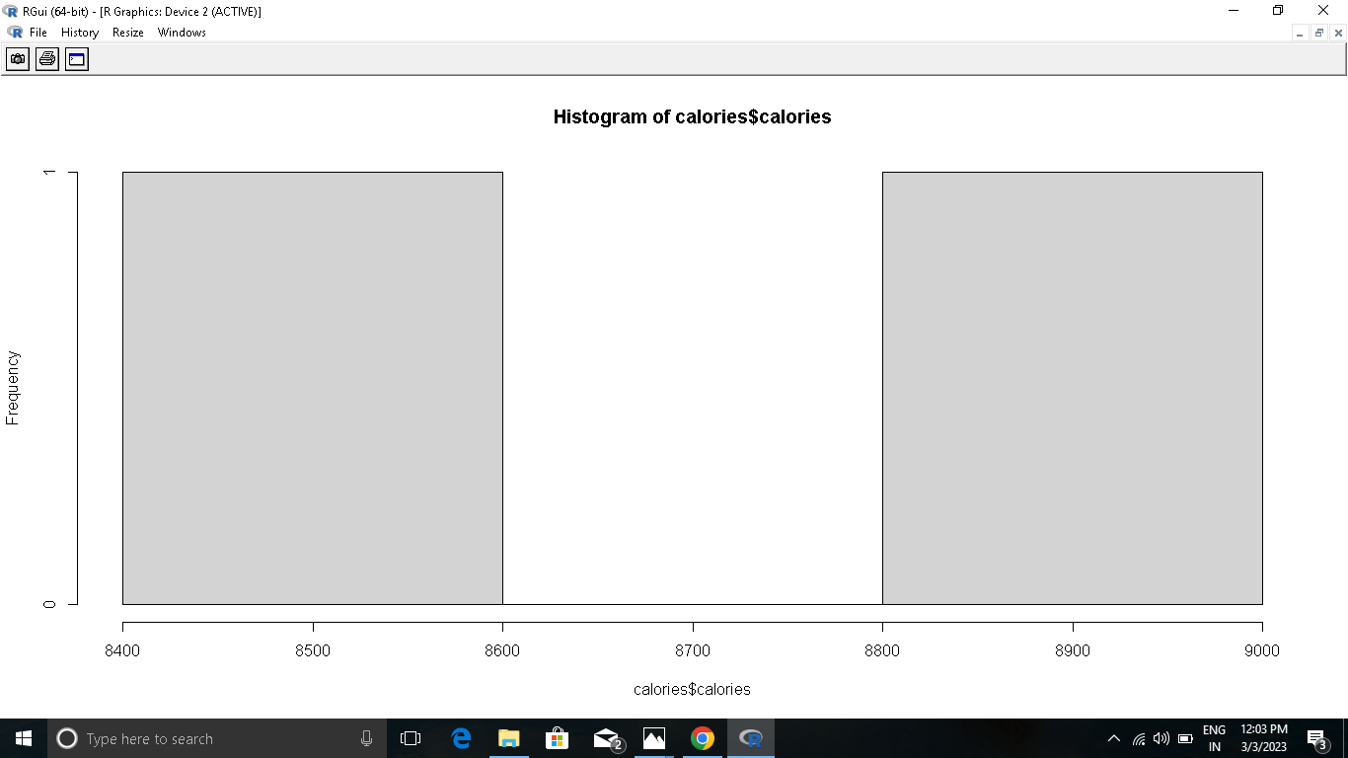

**Chapter - 10**

**CONCLUSION**

Models that could accurately predict outcomes based on input data.

Throughout the project, we explored various machine learning algorithms such as regression, decision trees, and random forests. We also utilized techniques such as cross-validation and parameter tuning to optimize our models for better performance.

Overall, the project has provided us with valuable insights into the potential of machine learning and its applications. We have learned that with the right data, tools, and techniques, we can create models that can help us make informed decisions, automate processes, and even discover new patterns and insights.

Moving forward, there is no doubt that machine learning will continue to play an increasingly important role in many fields, from healthcare and finance to marketing and engineering. As such, it is essential that we continue to explore and innovate in this area, pushing the boundaries of what is possible and findingnew ways to leverage machine learning for the benefit of society as a whole.